2022 Holy Spirit Parish

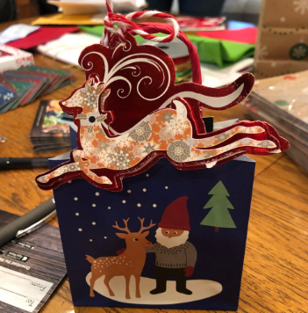
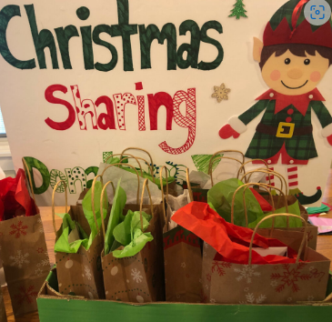

Christmas Sharing

Help us by opening your hearts & Adopt one of 20 Families


for Christmas
Sponsored by Holy Spirit Saint Vincent de Paul
Adoption signups: November 12 & 13 after each Mass
Contact for questions: Theresa White - (916) 601-2306

Donations are welcome online for Christmas Sharing as your designation on our Parish website
or by check to Holy Spirit Saint Vincent de Paul – Christmas Sharing.
