Society of Saint Vincent de Paul is hosting Water Bottles & Soap Drive for the needy in our community.

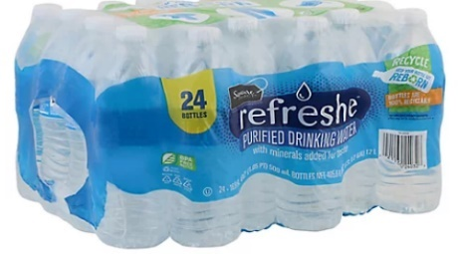
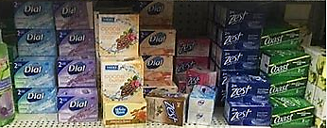

June 4 & June 11
After each Mass…
DONATION BINS
located in
FRONT/SIDE ENTRANCES


